6 calculus group task:

Edited at 2pm 1 February 2017.

1. Move 1 stick to make the expression correct.
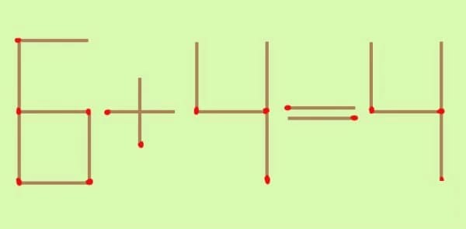
Give all the solutions.

2. Improve all your previous group tasks. Resubmit all previous group tasks.

Deadline: as soon as possible.

