Derivative is an instantaneous change. The derivative from the distance is velocity. The derivative from the velocity is acceleration.
Derivative is local linear operation. Derivative is a particular case of Taylor series.
Differentiability of a function is a tougher requirement than continuity of a function.
We consider derivatives of the main functions.
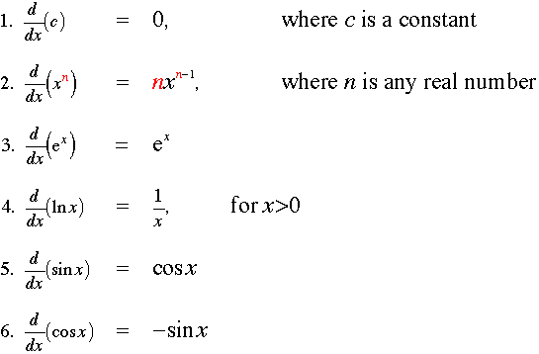
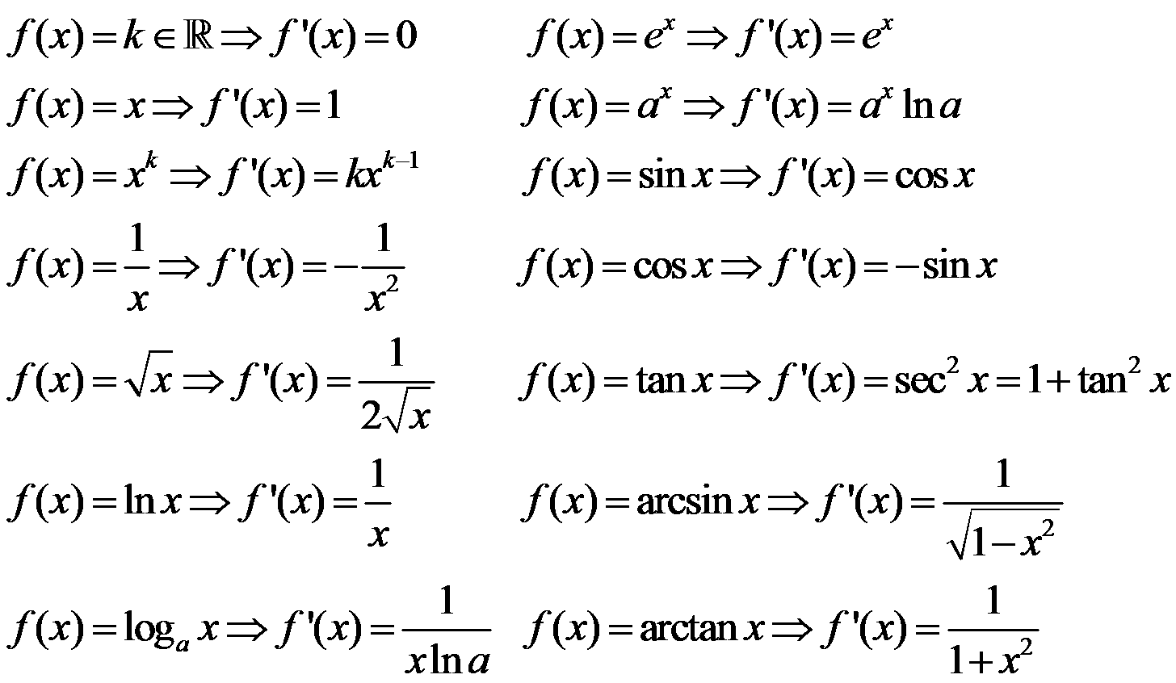
We use derivatives to find the intervals of monotony of functions, minima, maxima, inflection points, etc.
We introduce partial derivatives to calculate derivatives of composite function and implicit function.
We find the derivative of the inverse function as one over the derivative of the original function.
We solve optimization problems using derivatives: find a rectangle of perimeter P with maximum area.
If we have an equation which includes derivatives of unknown function then this equation is called a differential equation. We solve many differential equations in physics, chemistry, biology, economics, etc.
We classify the differential equations, identifying elliptic, parabolic and hyperbolic differential equations (similar to quadratic curves when we identified ellipse, parabola and hyperbola).

