**Main calculated indefinite integrals:**

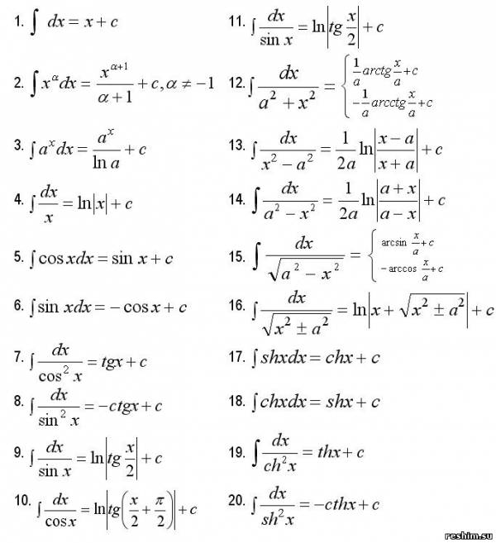

**1. Functions containing** http://latex.codecogs.com/gif.latex?%5Cinline%20%5Cleft%20%28%20a+bx%20%5Cright%20%29%5En,n%5Cin%20%5Cmathbb%7BZ%7D

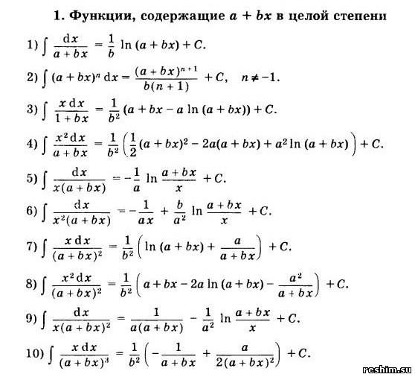  
  
  
**2. Functions containing**http://latex.codecogs.com/gif.latex?%5Cinline%20a%5E2+x%5E2,a%5E2-x%5E2,a+bx%5E2  
  
  
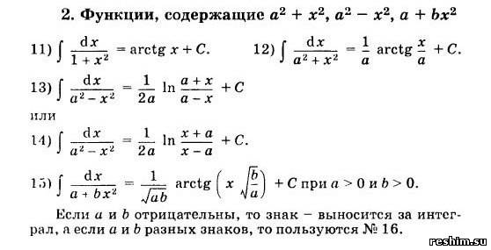  
  
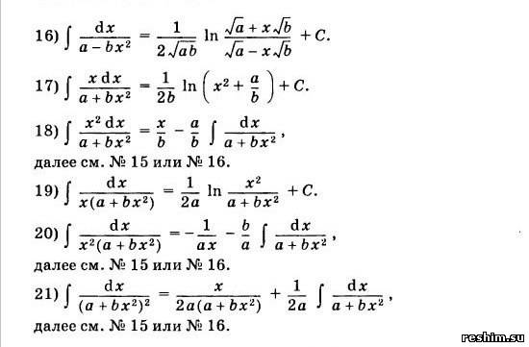  
  
**3. Functions containing**  http://latex.codecogs.com/gif.latex?%5Cinline%20%5Csqrt%7Ba+bx%7D  
  
  
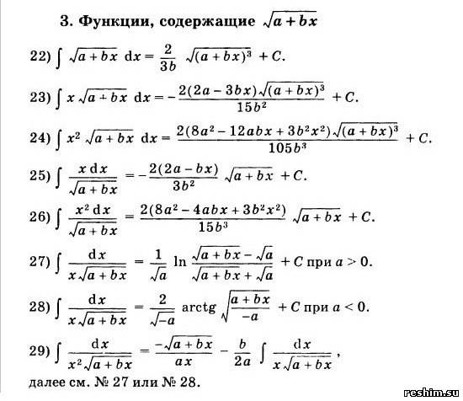

**4. Functions containing** http://latex.codecogs.com/gif.latex?%5Cinline%20%5Csqrt%7Bx%5E2+a%5E2%7D  
  
  
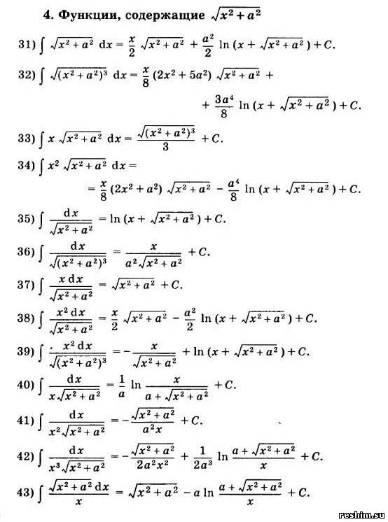

**5. Functions containing** http://latex.codecogs.com/gif.latex?%5Cinline%20%5Csqrt%7Ba%5E2-x%5E2%7D  
  
  
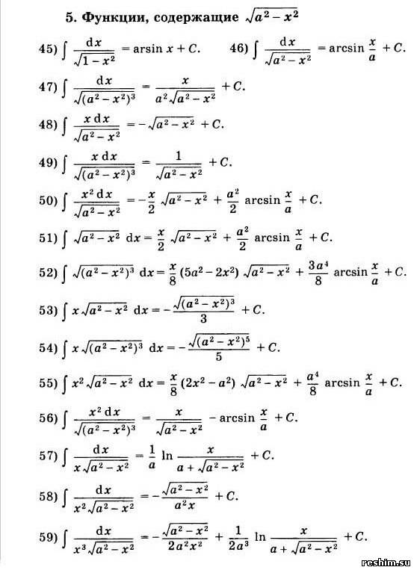

**6. Functions containing** http://latex.codecogs.com/gif.latex?%5Cinline%20%5Csqrt%7Bx%5E2-a%5E2%7D  
  
  
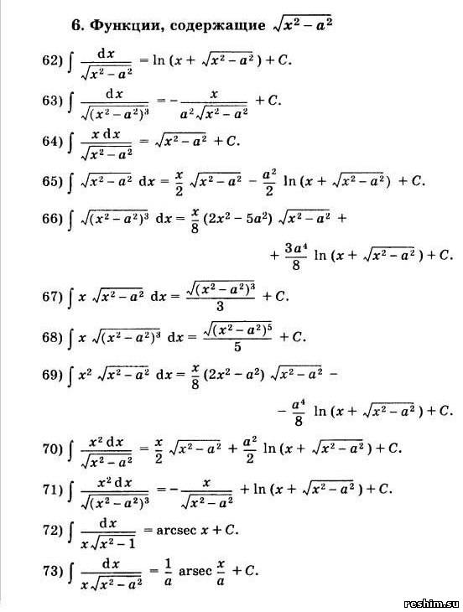  
  
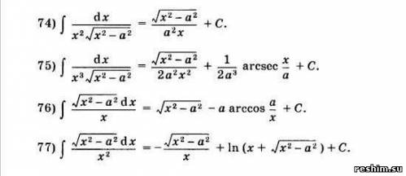  
  
 **7. Functions containing** http://latex.codecogs.com/gif.latex?%5Cinline%20%5Csqrt%7Bx%5E2-a%5E2%7D  
  
  
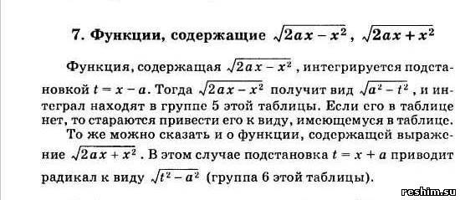

**8. Functions containing**  http://latex.codecogs.com/gif.latex?%5Cinline%20a+bx+cx%5E2%5Cleft%20,%28%20c%3E%200%20%5Cright%20%29  
  
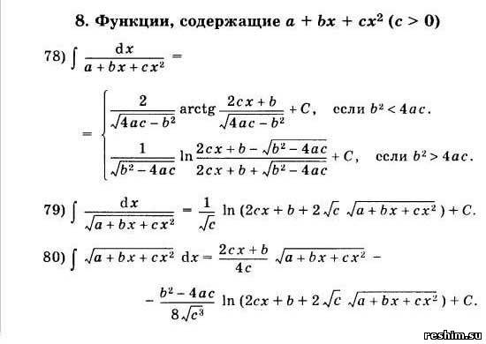  
  
  
**9. Functions containing**  http://latex.codecogs.com/gif.latex?%5Cinline%20a+bx-cx%5E2%5Cleft%20,%28%20c%3E%200%20%5Cright%20%29  
  
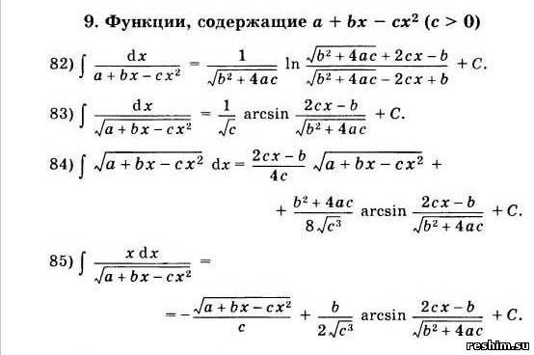

**10. Other functions:**  
  
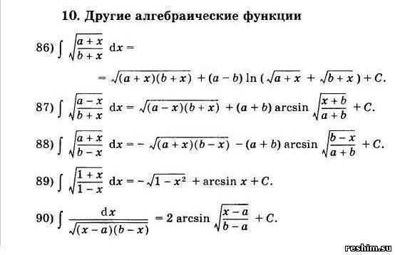

**11. Exponential and trigonometric functions:**  
  
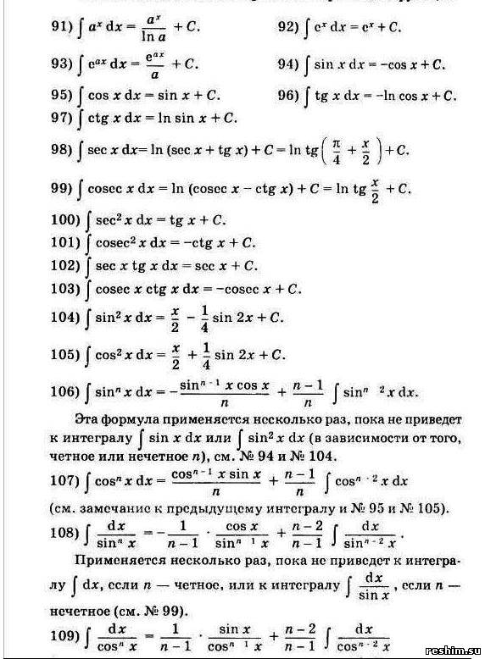

**12. Logarithmic functions:**  
  
